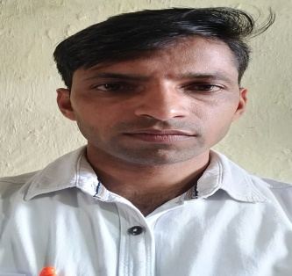 | Name : SHIWAL SINGH  Designation : Assistant Professor of Economics  Email : shiwalsingh9211@gmail.com  Qualification: M.A Economics, B.Ed., M.Phil, TET, SET, NET (JRF)  Total Teaching experience : 06 years

- Orientation Programme attended = 01
- Refresher Course attended = NIL
- Papers published in international journal =NIL
- Papers published in national journal =NIL
- Papers published in conference proceedings =NIL
- Published chapter in book =NIL
- Books published =NIL
- Conferences /seminars paper presentation=NIL
- Trainings /STC / workshops attended =NIL
- Any other information= FDP 01

Member of professional body /society /Honours /Awards/Recognition: NIL

