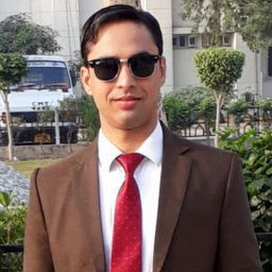 | Name: Dr. Inderjit Singh  Designation (Subject) : Commerce  E mail: indarjeet12@gmail.com  Qualification : M.Com, B.Ed, TET, M.B.A., UGC NET (JRF), SET, Ph.D  Total Teaching Experience: 8 Years

OP/RC/Training Programmes/Workshops attended/papers presented in conferences/Seminars, Publications etc.
- Orientation Programme attended = 03
- Refresher Courses attended = 03
- Papers published in International Journal: 10
- Papers published in National Journal: 08
- Papers published in conference Proceedings: 07
- Published chapter in Book = 15
- Books published (Text and reference)= Nil
- Conferences/ Seminars paper presentation = More than 50
- Trainings / STC / workshops attended = 09
- Any other information = More than 5 FDP

Member of professional body / Society /Honours/Awards/Recognitions:
- Life Membership in All Indian Accounting Association Shimla Branch.
- Ex Annual Member in Council of Research and Sustainable Development, Agra.
- International Professional Body Member of Dr. J.K. Research Foundation, Chennai (India).
- Life Membership in INSPIRA Research Association Jaipur (Rajasthan).
- Life Membership in APG Punjab.
AWARDS: 1. Rashtriya Gaurav Award and Certificate of Excellence by India International Friendship Society, August 2018,New Delhi
2. RashtraVidya Rattan Award by Achievers Association for Economic Research and Development, 12th April 2019, at Delhi

